


Prepare appetisers and salads
D1.HCC.CL2.12
Trainee Manual


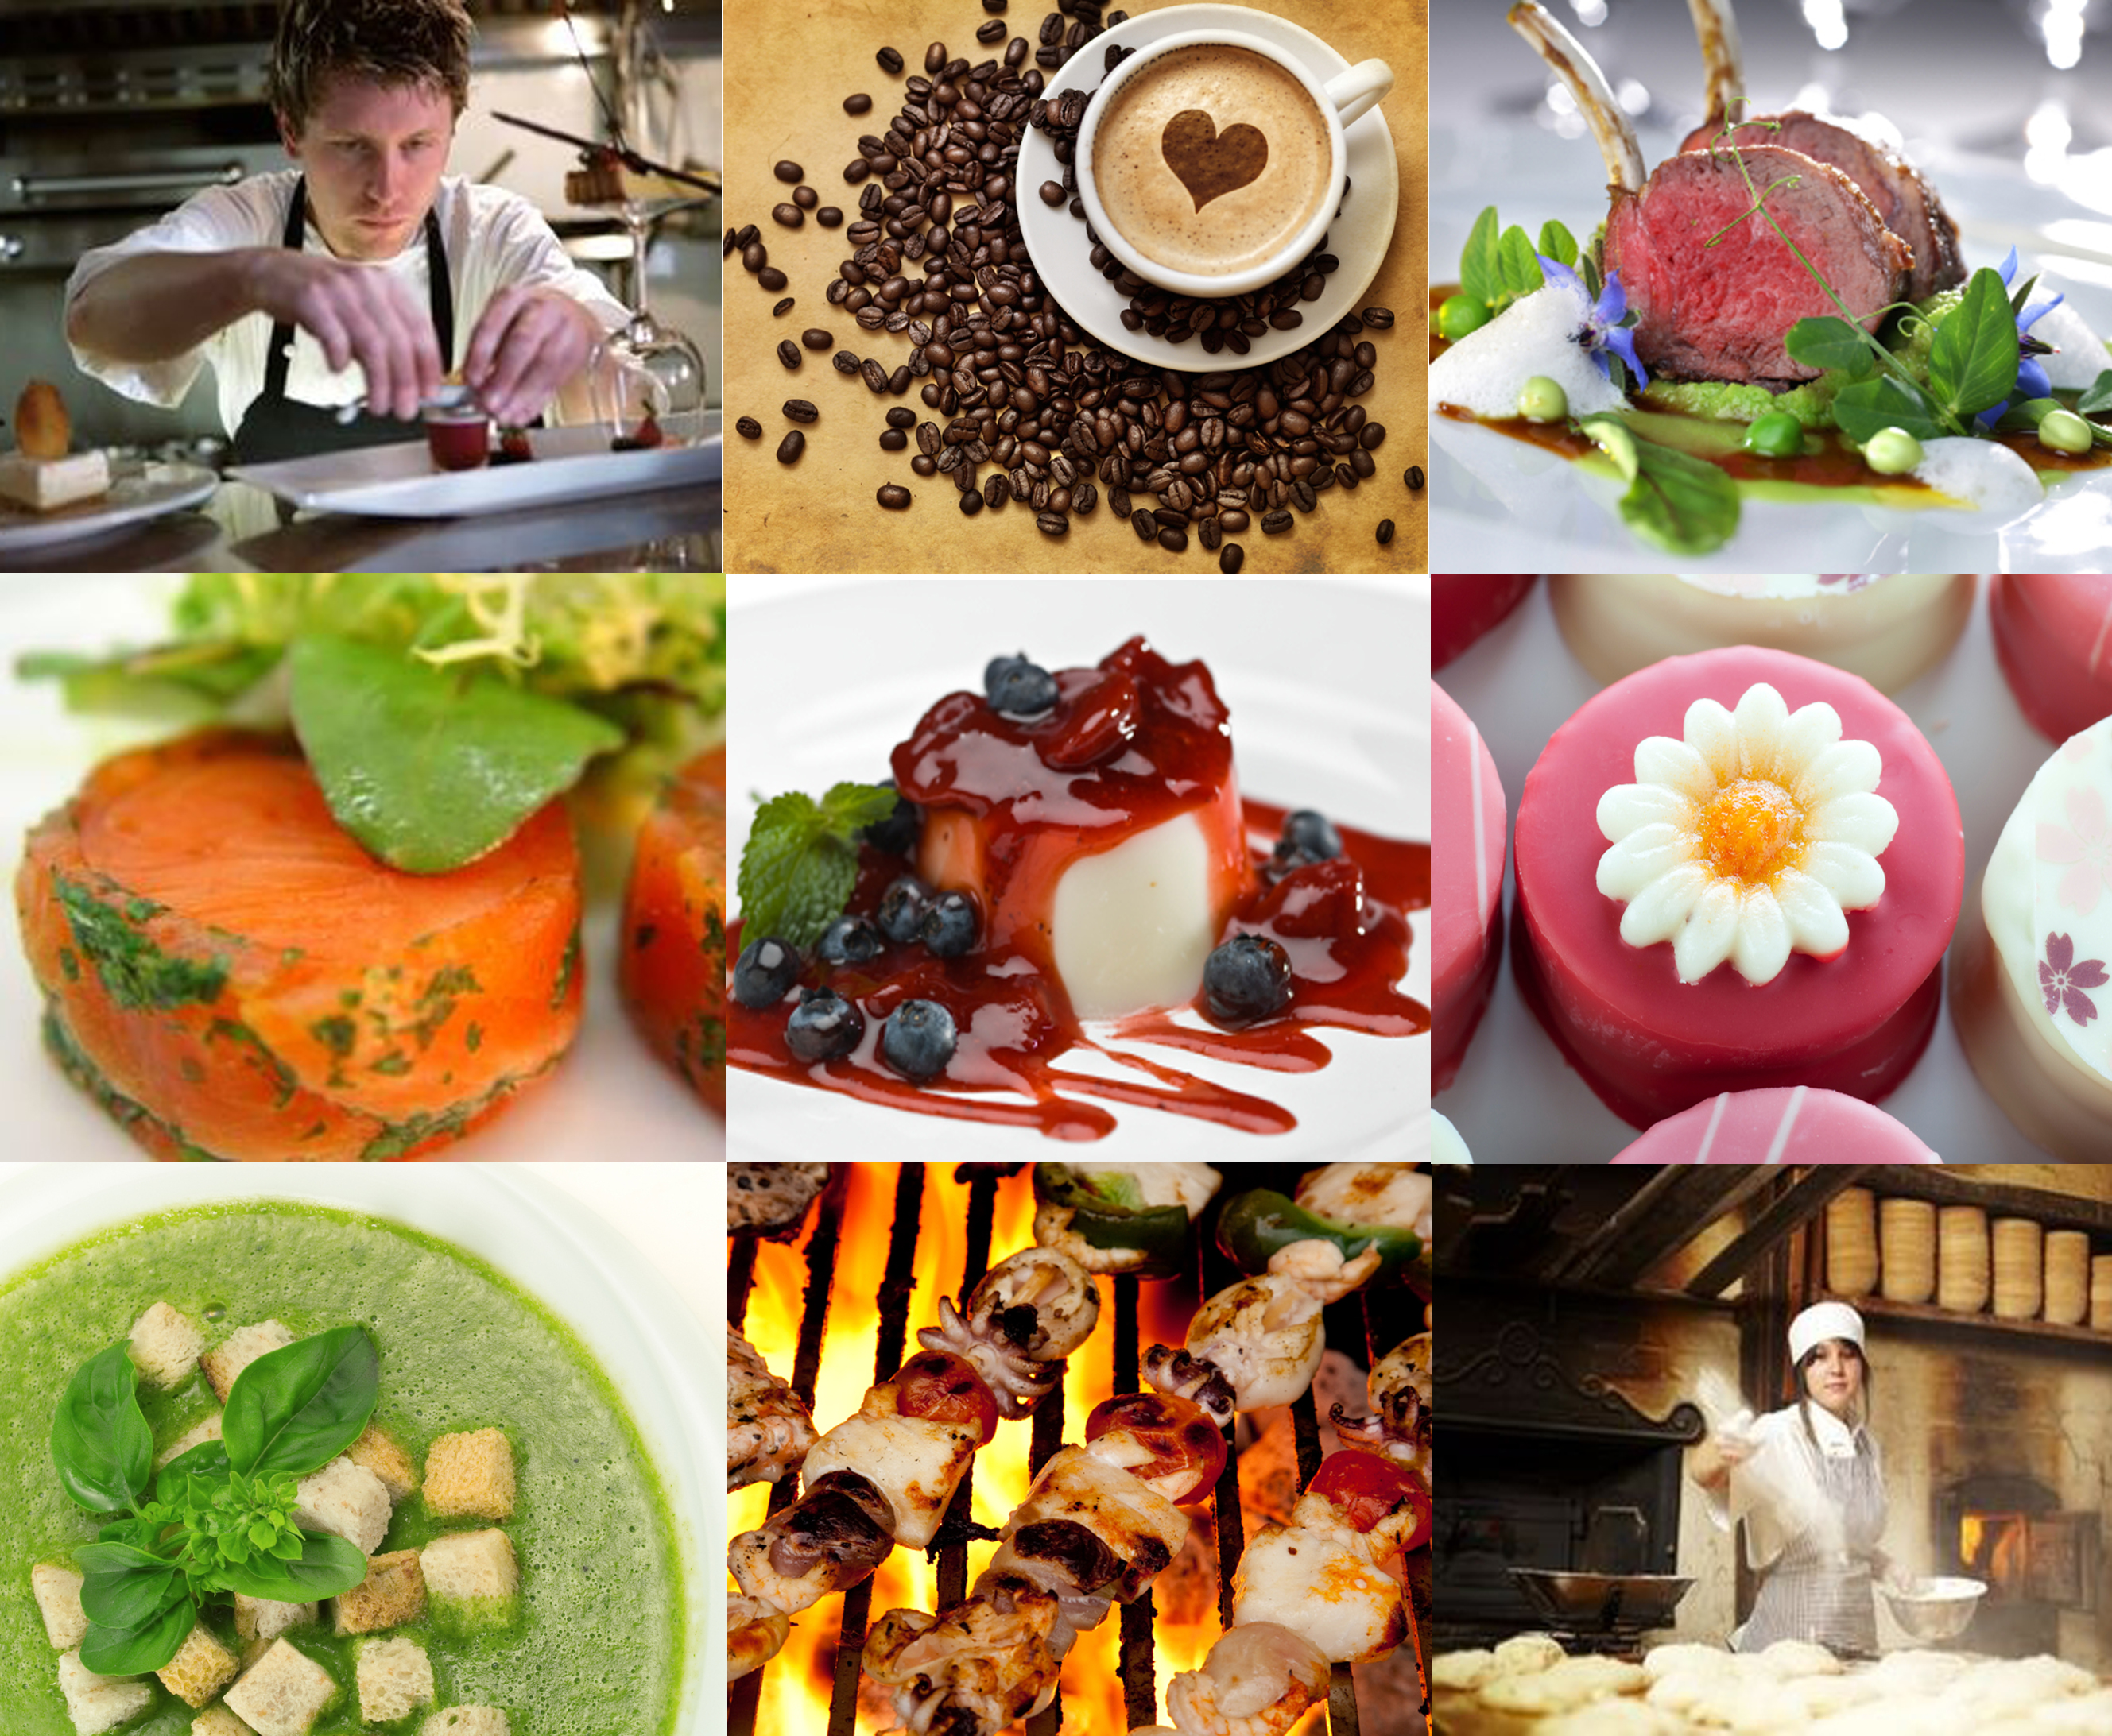



Prepare appetisers and salads

D1.HCC.CL2.12

Trainee Manual





Project Base
William Angliss Institute of TAFE
555 La Trobe Street
Melbourne 3000 Victoria
Telephone: | (03) 9606 2111
Facsimile: | (03) 9670 1330
Acknowledgements
Project Director: | Wayne Crosbie
Chief Writer: | Alan Hickman
Subject Writer: | Garry Blackburn
Project Manager: | Alan Maguire
Editor: | Jim Irwin
DTP/Production: | Daniel Chee, Mai Vu, Jirayu Thangcharoensamut, Kaly Quach

The Association of Southeast Asian Nations (ASEAN) was established on 8 August 1967. The Member States of the Association are Brunei Darussalam, Cambodia, Indonesia, Lao PDR, Malaysia, Myanmar, Philippines, Singapore, Thailand and Viet Nam.
The ASEAN Secretariat is based in Jakarta, Indonesia.
General Information on ASEAN appears online at the ASEAN Website: www.asean.org.
All text is produced by William Angliss Institute of TAFE for the ASEAN Project on “Toolbox Development for Front Office, Food and Beverage Services and Food Production Divisions”.
This publication is supported by the Australian Government’s aid program through the ASEAN-Australia Development Cooperation Program Phase II (AADCP II).
Copyright: Association of Southeast Asian Nations (ASEAN) 2013.
All rights reserved.
Disclaimer
Every effort has been made to ensure that this publication is free from errors or omissions. However, you should conduct your own enquiries and seek professional advice before relying on any fact, statement or matter contained in this book. The ASEAN Secretariat and William Angliss Institute of TAFE are not responsible for any injury, loss or damage as a result of material included or omitted from this course. Information in this module is current at the time of publication. Time of publication is indicated in the date stamp at the bottom of each page.
Some images appearing in this resource have been purchased from stock photography suppliers Shutterstock and iStockphoto and other third party copyright owners and as such are non-transferable and non-exclusive. Clip arts, font images and illustrations used are from the Microsoft Office Clip Art and Media Library. Some images have been provided by and are the property of William Angliss Institute.
Additional images have been sourced from Flickr and SKC and are used under Creative Commons licence: http://creativecommons.org/licenses/by/2.0/deed.en
File name: TM_Prepare_appetisers_&_salads_FN_090114





Table of Contents
Introduction to trainee manual 1
Unit descriptor 3
Assessment matrix 5
Glossary 7
Introduction 9
Element 1: Prepare and present a selection of hot and cold salads 11
Element 2: Prepare and present a selection of hot and cold appetisers 27
Element 3: Store appetisers and salads including garnishes and accompaniments 35
Appendix A: Salads 43
Appendix B: Appetisers 47
Presentation of written work 55
Recommended reading 57
Trainee evaluation sheet 59
Trainee Self-Assessment Checklist 61

Introduction to trainee manual

To the Trainee
Congratulations on joining this course. This Trainee Manual is one part of a ‘toolbox’ which is a resource provided to trainees, trainers and assessors to help you become competent in various areas of your work.
The ‘toolbox’ consists of three elements:
- A Trainee Manual for you to read and study at home or in class
- A Trainer Guide with Power Point slides to help your Trainer explain the content of the training material and provide class activities to help with practice
- An Assessment Manual which provides your Assessor with oral and written questions and other assessment tasks to establish whether or not you have achieved competency.
The first thing you may notice is that this training program and the information you find in the Trainee Manual seems different to the textbooks you have used previously. This is because the method of instruction and examination is different. The method used is called Competency based training (CBT) and Competency based assessment (CBA). CBT and CBA is the training and assessment system chosen by ASEAN (Association of South-East Asian Nations) to train people to work in the tourism and hospitality industry throughout all the ASEAN member states.
What is the CBT and CBA system and why has it been adopted by ASEAN?
CBT is a way of training that concentrates on what a worker can do or is required to do at work. The aim is of the training is to enable trainees to perform tasks and duties at a standard expected by employers. CBT seeks to develop the skills, knowledge and attitudes (or recognise the ones the trainee already possesses) to achieve the required competency standard. ASEAN has adopted the CBT/CBA training system as it is able to produce the type of worker that industry is looking for and this therefore increases trainees’ chances of obtaining employment.
CBA involves collecting evidence and making a judgement of the extent to which a worker can perform his/her duties at the required competency standard. Where a trainee can already demonstrate a degree of competency, either due to prior training or work experience, a process of ‘Recognition of Prior Learning’ (RPL) is available to trainees to recognise this. Please speak to your trainer about RPL if you think this applies to you.
What is a competency standard?
Competency standards are descriptions of the skills and knowledge required to perform a task or activity at the level of a required standard.
242 competency standards for the tourism and hospitality industries throughout the ASEAN region have been developed to cover all the knowledge, skills and attitudes required to work in the following occupational areas:
- Housekeeping
- Food Production
- Food and Beverage Service
- Front Office
- Travel Agencies
- Tour Operations.
All of these competency standards are available for you to look at. In fact you will find a summary of each one at the beginning of each Trainee Manual under the heading ‘Unit Descriptor’. The unit descriptor describes the content of the unit you will be studying in the Trainee Manual and provides a table of contents which are divided up into ‘Elements’ and ‘Performance Criteria”. An element is a description of one aspect of what has to be achieved in the workplace. The ‘Performance Criteria’ below each element details the level of performance that needs to be demonstrated to be declared competent.
There are other components of the competency standard:
- Unit Title: statement about what is to be done in the workplace
- Unit Number: unique number identifying the particular competency
- Nominal hours: number of classroom or practical hours usually needed to complete the competency. We call them ‘nominal’ hours because they can vary e.g. sometimes it will take an individual less time to complete a unit of competency because he/she has prior knowledge or work experience in that area.
The final heading you will see before you start reading the Trainee Manual is the ‘Assessment Matrix’. Competency based assessment requires trainees to be assessed in at least 2 – 3 different ways, one of which must be practical. This section outlines three ways assessment can be carried out and includes work projects, written questions and oral questions. The matrix is designed to show you which performance criteria will be assessed and how they will be assessed. Your trainer and/or assessor may also use other assessment methods including ‘Observation Checklist’ and ‘Third Party Statement’. An observation checklist is a way of recording how you perform at work and a third party statement is a statement by a supervisor or employer about the degree of competence they believe you have achieved. This can be based on observing your workplace performance, inspecting your work or gaining feedback from fellow workers.
Your trainer and/or assessor may use other methods to assess you such as:
- Journals
- Oral presentations
- Role plays
- Log books
- Group projects
- Practical demonstrations.
Remember your trainer is there to help you succeed and become competent. Please feel free to ask him or her for more explanation of what you have just read and of what is expected from you and best wishes for your future studies and future career in tourism and hospitality.

Unit descriptor
Prepare appetisers and salads
This unit deals with the skills and knowledge required to Prepare appetisers and salads in a range of settings within the hotel and travel industries workplace context.
Unit Code:
D1.HCC.CL2.12
Nominal Hours:
30

Element 1: Prepare and present a selection of hot and cold salads
Performance Criteria
1.1 Select ingredients to meet requirements of hot and cold salad menu items
1.2 Prepare salads to enterprise standards including nutritional and eating qualities
1.3 Prepare garnishes and accompaniments
1.4 Present salads including garnishes and accompaniments according to enterprise standards

Element 2: Prepare and present a selection of hot and cold appetisers
Performance Criteria
2.1 Select ingredients to meet requirements of hot and cold appetisers menu items
2.2 Prepare appetisers to enterprise standards including nutritional and eating qualities
2.3 Prepare garnishes, and accompaniments
2.4 Present hot and cold appetisers including garnishes and accompaniments according to enterprise standards

Element 3: Store appetisers and salads including garnishes and accompaniments
Performance Criteria
3.1 Store under appropriate conditions and locations to ensure freshness and quality
3.2 Store in appropriate containers
3.3 Labelling, storage containers
3.4 Ensure economic viability of preparation and holding quantities

Assessment matrix
Showing mapping of Performance Criteria against Work Projects, Written Questions and Oral Questions
The Assessment Matrix indicates three of the most common assessment activities your Assessor may use to assess your understanding of the content of this manual and your performance – Work Projects, Written Questions and Oral Questions. It also indicates where you can find the subject content related to these assessment activities in the Trainee Manual (i.e. under which element or performance criteria). As explained in the Introduction, however, the assessors are free to choose which assessment activities are most suitable to best capture evidence of competency as they deem appropriate for individual students.
 |  |  | Work Projects | Written Questions | Oral Questions
Element 1: Prepare and present a selection of hot and cold salads
1.1 | Select ingredients to meet requirements of hot and cold salad menu items |  | 1.1 | 1, 2, 3, | 1
1.2 | Prepare salads to enterprise standards including nutritional and eating qualities |  | 1.2 | 4 | 2
1.3 | Prepare garnishes and accompaniments |  | 1.3 | 5, 6 | 3
1.4 | Present salads including garnishes and accompaniments according to enterprise standards |  | 1.4 | 7 | 4
Element 2: Prepare and present a selection of hot and cold appetisers
2.1 |  | Select ingredients to meet requirements of hot and cold appetisers menu items | 2.1 | 8, 9 | 5
2.2 |  | Prepare appetisers to enterprise standards including nutritional and eating qualities | 2.2 | 10, 11 | 6
2.3 |  | Prepare garnishes, and accompaniments | 2.3 | 12, 13 | 7
2.4 |  | Present hot and cold appetisers including garnishes and accompaniments according to enterprise standards | 2.4 | 14 | 8
Element 3: Store appetisers and salads including garnishes and accompaniments
3.1 | Store under appropriate conditions and locations to ensure freshness and quality |  | 3.1 | 15 | 9
3.2 | Store in appropriate containers |  | 3.1 | 16 | 10
3.3 | Labelling, storage containers |  | 3.1 | 17 | 11
3.4 | Ensure economic viability of preparation and holding quantities |  | 3.2 | 18 | 12

Glossary
Term | Explanation
Acidulated | Acidic in nature, Vinegar is acidic
Appetisers | Small snack served before the main meal, 'amuse gueule', finger food, cocktail party food
Aramrath | Mild tasting herb: Chinese Spinach
Barquette | Small boat shaped pastry to hold soft filling and garnishes
Bouchee | Small vol au vent pastry case, 4 cm, in diameter, savoury in taste
Canapés | Small one or two bite snack, savoury in taste, firm base-topping- garnish
Complex | Ingredients might need to be cooked before incorporating into salad
Coriander | Cilantro or Chinese parsley, native of Central America, essential in Thai cuisine
Croutons | Fried bread, adds textural diversity to dishes
Dim Sum | Chinese snack food
Dressing | Moisture added salads to lubricate the dish, will have seasoning, will be acidic in nature, vinegar based normally
Emulsifier | Ingredient that will bind two otherwise non-binding ingredients. In making mayonnaise, the egg yolk contains LECTHIN. Lecithin is an emulsifying agent. Lecithin is also found in soya beans
Emulsion | Binding of two product that would not normally bind
Fold | technique to incorporate ingredients slowly and aimed at not causing too much damage to ingredients
Fritter | Fried batter, can be flavoured of can be something encased inside. Fried in deep fat or on grill plate
Gyoza | Small Asian style dumpling, will be steamed in small amount of liquid and as liquid evaporates the outside pastry will begin to fry, leaving a crispy edge to dumpling
Lemon Grass | Grass like herb, essential in South East Asian Cuisine; commonly in Thai cuisine
Lettuce | Native to Mediterranean, known in Egypt for 2500 years, known in Asia Minor (Persia), member of the sunflower or thistle family
Mayonnaise | Emulsion of egg yolk and oil with vinegar. Used as a salad dressing. Many variations
Meze | Greek snack food
Pandanus | Spear shaped leaf, versatile in cooking, nutty like flavour, savoury or sweet dishes, Available fresh, frozen, canned or dried
Parsley | A green herb related to carrots, parsnip and dill. Large flat leave, Continental parsley, stronger in flavour than English parsley
Salad | Mixture of leafy vegetables, normally served cold, can incorporate meats and cooked root vegetables
Samosas | Indian snack pastry, small version make excellent finger food
Savouries | Small finger food that does not contain sugar, is savoury, not sweet
Simple | Simple, one or two ingredients
Sushi | Japanese snack food associated with vinegared rice
Tapas | Spanish style snack, mainly served in bars, Tapas bars are very popular in Spain and Spanish influenced countries
Tapas | Spanish snack food
Toss | Technique to cover leaves with dressing so even coating is acquired
Turmeric | A member of the Ginger family. Used in many dishes for both its colour and flavour
Vinaigrette | Mixture of oil and vinegars, used to add flavour to salads as dressing

Introduction

Salads
Definition
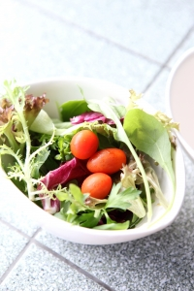
‘Salad’ is a broadly used term to describe a dish (or series of dishes) which are prepared with one ingredient as the feature, or a combination of ingredients and flavours.
What foods can be in a salad? Any foods can be in a salad.
In the warm climate countries like Australia, salads have played, and will continue to play, an important role in culinary tastes.
‘Salads’ offer a refreshing cool and alternative method of consuming food
It is also an area where a chef can create highly original work.
A salad can be served in the following ways:
- Cold or warm
- Raw, cooked, or a combination of raw and cooked
- Fruit only, vegetables only, or a combination
- As a starter, main course, meal accompaniment (in place of vegetables) or in its own right on a buffet table.
Salads, as they are understood and perceived by western cultures, are usually vegetable based, and feature leafy greens.
This definition, whilst clear to those who have established knowledge, does not, however, provide a comprehensive classification of salads.

Classifying salads
The easiest way to establish where salads fit in the scheme of things is to classify them in the following ways:
Simple
A salad where one ingredient is the main feature: it is usually a vegetable or leafy green or tomato based and may have dressing added.
Examples include:
- Tomato salad
- Lettuce salad
- Cucumber salad.
Mixed/Compound
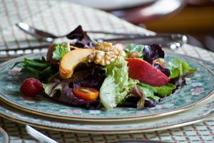
A salad that has two or more main ingredients as well as dressing
Examples include:
- Coleslaw (shredded cabbage, onion, carrot and capsicum with mayonnaise or simple vinaigrette dressing)
- Tabouli salad (parsley, onion, tomato and buckwheat)
- Greek salad. (tomato, cucumber, onion, black olive, fetta cheese, dressing, herbs)
Classical Salads
Based on French cuisine:
- This term refers to all traditional salads which are based on French-influenced cuisine and tradition
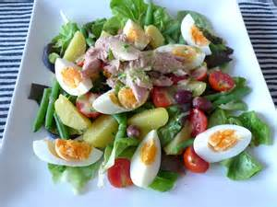
- Examples include:
- Salade Nicoise (French beans, potatoes, tomatoes, anchovy, olives, capers and French dressing)
- Salade Waldorf.(celery, apple, chopped walnuts, mayonnaise and cream).
Modern Salads
A term used to classify any contemporary developments in salads, which may use previously unavailable ingredients or adopted international cuisines, particularly Asian and Italian or Mediterranean.
Examples of ‘modern’ styles of salads include:
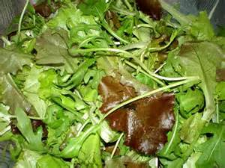
- Thai Beef Salad (thin sliced strips of cooked beef, crushed peanuts, mint, coriander, bamboo shoots, vegetable strips such as , palm sugar, soy, ginger, garlic, chilli and lemon juice)
- Mesclun (array of leafy greens, i.e. radicchio, rocket, mâche, mignonette, butter, endive, cos and oak leaf)

Element 1:
Prepare and present a selection of hot and cold salads

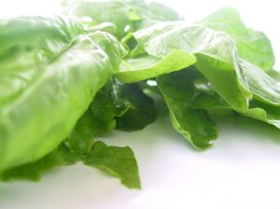
1.1 Select ingredients to meet requirements of hot and cold salad menu items

Salad greens
The expression ‘leafy green’ is usually used to describe leafy lettuce. The variety of lettuces in Australia has increased quite markedly from the mid-1980s onwards. Some of the more commonly available ‘leafy greens’ in Australia include:

Iceberg | Cos | Radicchio
Mignonette | Butter | Curly endive
Witlof (Belgian endive) | Rocket | Mâche (lambs lettuce)
Oak leaf | Mustard cress | Watercress
Bean shoots | English spinach | Silverbeet
Snow pea sprouts | Alfalfa sprouts

Asian salad greens
Amaranth  English: Chinese Spinach  Chinese: Een Choi  Bahasa: Bayam  Thai: Phak Khom Suan | Asian Basil  English: Malabar Spinach  Chinese: Kai Lan  Bahasa: Selaseh  Thai: Horapa | Ceylon Spinach  English: Malabar Spinach  Chinese: Saan Choi  Bahasa: Remayong  Thai: Phak Plang
Pennywort  English: Indian Pennywort  Thai: Bua Bok |  | La pot  English: Wild Betel  Bahasa: Duan Kadok  Thai: Bai Chaplu
Coriander  English: Coriander, Cilantro  Chinese: Uen Sai  Thai: Pak Chee | Pea shoots  English: Pea Shoots  Chinese: Dau Miu  Thai: Pak Tua Lan Tao | Perilla  English: Beefsteak Plant  Chinese: Gee So, Jen  Japanese: Shiso
Source: marketfresh.com.au Asian vegetable and herb guide
To increase your own knowledge you must start to acquire a library of personal resource list of ingredient names:
- What is available at your local supplier?
Market fresh website
www.marketfresh.com.au
Find it; use it, valuable source of information.

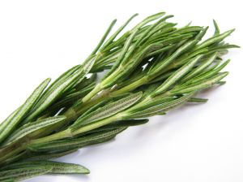
Salad Herbs
A ‘herb’ is a flowering plant with a stem that does not become wooden, but decays and regenerates annually.
Herbs have a variety of uses, including medicinal, taste and smell.
Food service professionals are more concerned with taste and smell, and in this context, the herb must be suitable for eating by humans without adverse side effects.
Herbs are used in salads to provide flavour, aroma and texture, but care must be taken (due to strength and overpowering flavour) not to add excessive amounts.
Some herbs that are popular in salads include the following:
Curly parsley | Italian parsley |  | Mint
Thyme | Coriander |  | Marjoram
Oregano | Basil |  | Purple basil
Ornamental basil | Rosemary |  | Dill
Fennel | Spearmint |  | Tarragon
Vietnamese mint (spicy)

Salad Vegetables
Any vegetable can be used in salads. Some root vegetables will need to be cooked before they are edible in a salad. Example: potato, pumpkin, sweet potato.
Swedes and turnips tend not to make good salad vegetables.
Vegetables are broken into 2 main categories.
Root Vegetables include vegetables derived from roots, bulbs and tubers of plants.
Green Vegetables Include vegetables derived from leaves, stems, flowers, fruits, legumes and seeds of plants
Root vegetables suitable for salads
Carrot | Can be raw, shredded, sliced or cut to size, roasted to add extra flavour then chilled for salad
Parsnip | For salad is best roasted then chilled
Radish | Served raw, sliced or quartered
Onion | Can be used raw, thinly sliced or roasted. Many varieties
Potato | Needs to be cooked boiled or oven roasted
Sweet Potato | Needs to be cooked boiled or oven roasted
Beetroot | Can be shredded and eaten raw but is best served separate as it will stain everything. Normally boiled allowed to cool
Leaf vegetables suitable for salads
Cabbage | Can be raw, shredded, sliced or cut to size, addition of vinegars break down leaf structure
Lettuce | Always a base with other vegetables to add interest:  Refer salad greens previous pages
Spinach | Served raw, baby spinach best for salads
Witlof | Used raw, thinly sliced or roasted.
Stem Vegetables suitable for salads
Asparagus | Can be blanched quickly then refreshed, grilled and then chilled
Celery | Slice thinly
Fennel | Shaved thinly
Bamboo shoots | Canned, thinly sliced

Flower Vegetables for salads
Broccoli | Blanched then chilled
Cauliflower | Blanched or roasted, then chilled
Fruit vegetables for salads
Avocado | Many varieties, diced and tossed with dressing
Capsicum | Many varieties, can be raw or roasted
Cucumber | Raw, sliced thinly or cubed
Eggplant | Thinly sliced then grilled, chilled
Tomato | Many varieties, sliced and chopped
Zucchini | Thinly sliced then grilled, chilled
Legumes for salads
Beans, Green | Blanched then chilled
Chick peas | Soaked then poach until tender, chilled
Sweet corn | Boiled then chilled
Peas | Blanched then chilled
Web reference
http://www.marketfresh.com.au/mf.asp
Click on the market fresh dropdown at the top left corner:
- Downloads
- Vegetables
- Fruits
- Tropical fruits
- Asian vegetable and herb Guide.

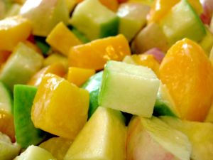
Salad Fruits
Everything You Need To Know About Fruits
Fruits are classified into the following groups:
Soft fruits | Strawberries, raspberries, blackberries, boysenberries, blueberries, gooseberries, grapes and currants (red, black & white).
Stone fruits | Apricots, peaches, nectarines, plums, mangoes, cherries.
Hard fruits | Apples, pears and quinces
Citrus | Lemons, oranges, grapefruit, mandarins, cumquats, limes, pomelo, tangelo
Tropical | Bananas, pineapple, lychee, rambutan, jackfruit, dragon fruit, guava, tamarillo, pawpaw, custard apple
Miscellaneous | Rhubarb, kiwifruit, persimmon, passionfruit, pomegranate, fig, watermelon, cantaloupe, honeydew
The following fruit categories have other quality points such as:
Soft fruits | Mould free  Dirt free
Stone fruits | Mould free  Not bruised
Hard fruits | No bruising
Citrus | Mould free  Skin to be firm, not soft
Tropical | No bruising
Miscellaneous | Good colour  Firm to touch  Melons should be heavier than they look

Salad farinaceous ingredients
Pasta, lentils, beans, cous cous,
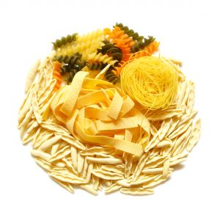
Salads have always been a good way of using left over pasta.
Pasta does not have a flavour of its own.
The texture of pasta or noodles is what is important. Give it a well rounded sauce and it will bulk salad very well.
Pasta needs to be cooked al dente, but some people like to cook it more when used in salad.
Cold pasta is nutritionally very good for the human gut.
Cooked lentils and beans are nutritious and are excellent additions to salads. They offer textural diversity.

Meats for salads
- Cooked, cold
- Meats cured, cold or warm.
Salad meats
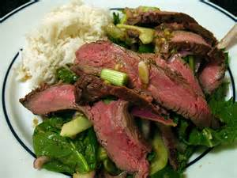
- Bacon, crisped in fry pan then chilled
- Chicken, poached, roasted
- Beef
- Lamb
- Sausages.
These meats would be cooked then chilled.
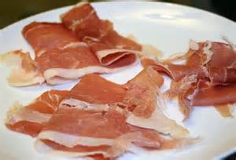
Cured meats
- Prosciutto
- Bresaola
- Salami
- Ham.

Cured vegetables
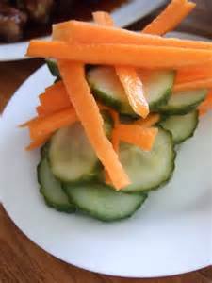
- Olives, black and green
- Pickled cucumber, savoury and sweet
- Onions
- Cauliflower.
Many vegetables can be preserved in vinegar solution and then used in salad dishes.

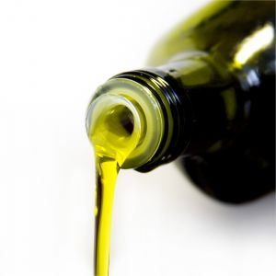
Oils
Definition
Edible oils group all fats which are liquid at room (or near room) temperature. They are used in salads for flavour, overall texture and balance.
Types
The number of oils that can be used to make salads is only limited by imagination, practicality and availability. The following list highlights some of the more commonly used oils:
Neutral flavour and aroma
Sunflower | Safflower | Grape seed | Canola
Strong or noticeable flavour and aroma
Olive  Virgin olive | Walnut  Hazelnut | Rose (strong and expensive)  Truffle (expensive) | Chilli (very strong)  Sesame

Vinegars

Definition
Vinegar is an acidic liquid made by fermenting wine, cider, sherry, etc. Due to its acidity, it is used for preserving food, as an accompaniment, or as part of a dressing in a salad. The actual sourness of the vinegar accentuates the flavour of the ingredients used in salads.
Types
Whilst there may be a wide range of flavoured vinegars available, i.e. herbed, and spiced, etc., most vinegars have been made from a wine, sherry or cider base. Some of the more common vinegars available for salad making include:
- White wine
- Red wine
- Cider
- Balsamic (unfermented white wine base)
- Malt
- White
- Flavoured (e.g. Tarragon).

Dressings/sauces
Definition
Dressings are prepared liquids (sometimes thickened) that make a salad more appetising in appearance and flavour.
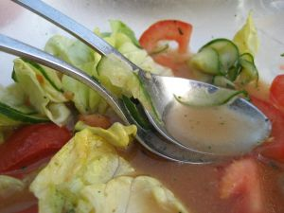
To establish the most appropriate dressing for a particular salad, the following areas need to be considered:
- What type of salad is being prepared?
- Is the purpose of the dressing to add flavour only (vinaigrette) or to bind (mayonnaise)?
- Will dressing be served in or next to the salad?
- Is the dressing compatible with the flavour of the salad?
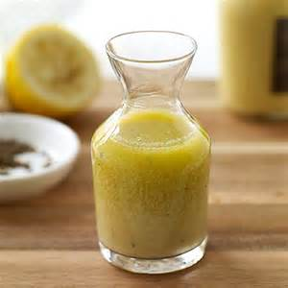
Types: Vinaigrette
Also known as French dressing, a traditional vinaigrette is a combination of vinegar, oil and seasoning. These ingredients are mixed together vigorously just before use.
Vinaigrette also accentuates flavour and gives moisture to a salad. The recommended proportions of a basic vinaigrette are three parts oil to one part vinegar.
Types: Mayonnaise
Mayonnaise is actually considered a cold sauce and its main ingredients include oil, vinegar, mustard, egg yolks and seasoning.
It is also known as an emulsion sauce because two incompatible ingredients, oil and acid (vinegar), are combined through an emulsifying agent (egg yolk).
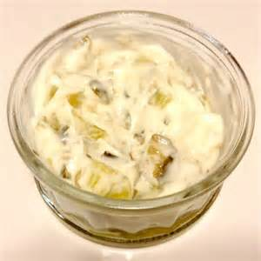
Flavours, herbs and garnishes can be added to form the basis of a derivative sauce (a sauce that has been made using the mayonnaise as the main part).
Some examples of derivative sauces using mayonnaise as a base include:
- Tartare sauce: mayonnaise, capers, gherkins, dill, parsley and lemon juice
- Cocktail sauce: mayonnaise flavoured with tomato sauce, Worcestershire sauce and lemon.
Flavour variations: tips
- Try different flavoured oils in a dressing and notice the difference
- Lemon juice can be added in place of vinegar
- Add finely chopped parsley or chives to dressing or mayonnaise for added colour and flavour.

Reasons for Dressings
Dressings are used to
- Lubricate
- Flavour
- Add food value
- To bind together
- Adds shine and gives pleasing appearance.

Portion control and storage
Portion control
It is important to know how much dressings or cold sauces have to be made for a given situation.
This can be maintained in two ways.
- Manufacturing dressings and sauces on a litre basis ‘as required’, daily or weekly
- Making dressing/sauces on a per person basis.
- This is particularly useful when making unusual or uncommon sauces. Approximately 30ml finished dressing/sauce per person should be allowed.
Storage
Dressings
Vinaigrette has no ingredients requiring refrigeration.
To ensure that there is absolutely no threat of food spoilage, however, it is advisable to keep this dressing in a refrigerated area and covered in an airtight container (glass or stainless steel).
Do not freeze. Shake vigorously before use.
Mayonnaise
Mayonnaise or its derivatives should be kept in a refrigerated area and covered in an airtight container; preferably glass or stainless steel.
Do not freeze.

1.2 Prepare salads to enterprise standards including nutritional and eating qualities

Introduction
Salads should be made as close as possible to the required time of service. Some salads, however, will require storage to allow flavour absorption, e.g. marinated red pepper salad.
These types of salads should be stored in an airtight container with lid in a refrigerated area.
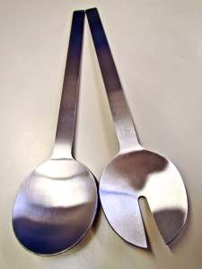
If salads do not require soaking or marinating, they should be stored in airtight containers with lids in a refrigerated area.
Dressing or sauce should be kept separate.
Salads should not be frozen.
The majority of salads are served cold. Some ingredients are served raw while others are cooked and then cooled before using in the salads.
The variety of salad ingredients in unlimited
Traditionally a salad should be light and refreshing to cleanse the palate. But as eating habits change so does the role of the salad.
Today salad can be the meal, with or without meat.
Salads can also be warm.
Example: Hot chicken livers with hot sherry dressing tossed over cold salad leaves.
Modern salad dishes tend to have cultural influences as well as countries become influenced by other cultures.
Preparing salads
Salad preparation is no different to any other dish
- Mise en place. ‘Everything in place’ before you start.

1.3 Prepare garnishes and accompaniments

Introduction
Garnishes are prepared as part of your normal mise en place:
- Herbs can be chopped to sprinkle over top of finished salad for flavour and eye appeal
- Herb sprigs can be used to decorate top of salads
- Thin slices of vegetables: julienne of carrot, slivers of spring onion

- Nuts, roasted and chopped to add flavour
- Fried bread pieces or Oven roasted
- Deep fried shaving of vegetables.
Accompaniments
Sauces and/or dressings
Dressings can be classified into two types:
- Vinegar based
- Mayonnaise based.
Vinaigrette based sauces can be value added:
- French
- Roquefort, blue cheese added to vinaigrette or
- Other flavour added to base dressing.
Mayonnaise based dressing:
- Caesar.
Holding and storage conditions
Salads with leaves and herbs will not hold well after the dressing has been applied.
Vinegar will cause the leaves to wilt. Do not dress the salads too soon.
Salads can be mixed then stored. Do not dress then store.
Salads leaves will have a comparatively short lifespan.
Cutting techniques, size and shape
As cultural diversity comes into the menu so will the expectation of preparation styles.
Many Asian styles will incorporate intricate styles of cutting.
Some special tools are available to replicate this in the modern world but when it comes to pay higher wage costs outside of the Asian region it become unviable to do this elaborate vegetable carving.
Modern machines will now to do the bulk of large scale dicing and slicing.
1.4 Present salads including garnishes and accompaniments according to enterprise standards

Introduction
A well presented salad will have the following characteristics.
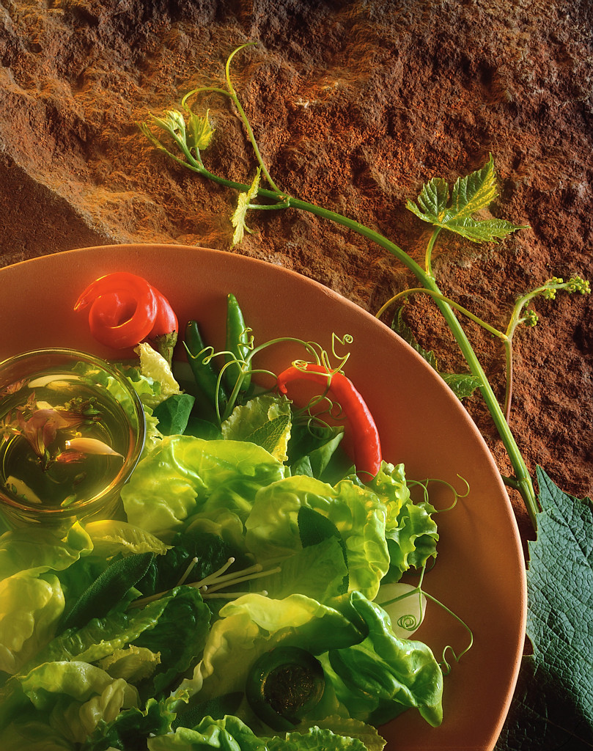
Leaf Salads
- It will have a shine
- Lots of colour
- It will have height before width
- It should be appealing to the eyes
- Textural diversity adds to the eating experience.
All this before the customer has even tasted the salad.
When presenting the salad certain points need to be considered.
Type of service
Formal
- Served in restaurant as a side dish to the main meal.
Casual
- Served as part of the buffet.
Modern
- Served in café as a meal that will stand alone.
Stand up or sit down
- Some salads are now being served in wraps, type of sandwich.
Salads traditionally have been served as a palate refresher.
Modern interpretations make it:
- A meal on its own
- An alternative to hot vegetables
- A side dish.
It is good to have a refreshing salad after eating grilled steak to cleanse the palate.

Work Projects
It is a requirement of this Unit you complete Work Projects as advised by your Trainer. You must submit documentation, suitable evidence or other relevant proof of completion of the project to your Trainer by the agreed date.
Gather the following information from your local supplier
1.1 What salad ingredients are available from your local supplier?
1.2. Select a recipe from the appendices in the back of this book.
1.3. Prepare suitable garnish for this recipe.
1.4. Present this salad to your instructor for evaluation.

Websites for ideas:
Kraft foods – http://www.kraft.com.au/recipecollections/international/asiansnacksandappetisers.aspx
Wheel and Barrow, Australia – http://www.wheelandbarrow.com.au/recipes/appetisers/

Summary

Prepare and present a selection of hot and cold salads
Select ingredients to meet requirements of hot and cold salad menu items
It is important to be able to use the correct ingredients that the recipe says. In this modern age of mass transportation people come from all over the world.
If you are going to make a salad that is from German cuisine then you need to make sure that you are able to get ALL the ingredients in the recipe. Trying to serve something similar can be disastrous.
Understand what you are going to make and select ingredients accordingly.
Buy ingredients fresh and of a quality expected by your clients.
Prepare salads to enterprise standards including nutritional and eating qualities
Prepare salads fresh
Apply dressing in a timely manner, not too soon on leafy ingredients.
Prepare garnishes and accompaniments
Garnishes should be prepared fresh
They should complement the main component of the dish
Accompaniments can offer textual diversity to the dish.
Accompaniments like pickled vegetables, sauces and chutneys can be prepared in advanced as long as storage requirements are in place.
Present salads including garnishes and accompaniments according to enterprise standards
Salad presentation should have look of freshness. The WOW factor. Salads should look inviting to eat and be presented on good quality service ware.

Element 2:
Prepare and present a selection of hot and cold appetisers

2.1 Select ingredients to meet requirements of hot and cold appetisers menu items

Introduction
Classic interpretation:
Classically Appetisers are known as hors d´oeuvres, which literally means ‘outside the work’.
They are small dishes comprising of one to three bites.
Originally Appetisers were the responsibility of the stills room, hence outside of the kitchen.
Appetisers were both hot and cold and served before a meal to give the guest an idea of the standard of food to follow and to also start the gastric juices flowing.
The main difference between a canapé and an appetiser is an appetiser is eaten sitting down at the table with a knife and fork.
Modern interpretation:
In Australia today Chefs view appetisers very differently.
Appetisers are strictly now prepared in the kitchen and range from basic to complex.
An appetiser (sometimes referred to as “amuse gueule” or “amuse bouché”) is still served at the beginning of a meal before the entree but after the order for the meal is taken.
“Amuse gueule” are not ordered and are seen as a ‘gift’ from the kitchen in the same vein as petit fours.
They are a chance for the kitchen to be creative and experiment with flavour combinations for future use on menus.
Sometimes they can be mini versions of a dish that a chef wish to test for a future menu, or items that the chef needs to get rid of.
They can be served hot or cold and can be served using a variety of crockery, ranging from side plates to small espresso cups.
Today’s chef still factors in the idea of an appetiser whetting the appetite and starting the gastric juices.
‘Finger Food” is the name a lot of people use for stand up ‘cocktail party food’.

Savouries
Definition
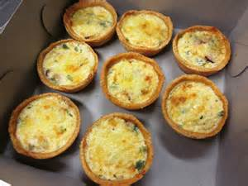
Savouries are small portions of hot food served with pre-dinner drinks or stand up function, served at the table as a hot appetiser.
They are served hot and are usually served with a dipping sauce.
The following are some examples of savouries:
Mini quiche  Satay  Wontons  Meatballs  Spinach and Fetta triangles | Shot glasses filled with soups  Mini dim sim  Mini spring rolls  Goujons  Samosas

Canapés
Definition
Small, Savoury, Bite Sized Finger Food:
- Are served with pre-dinner drinks or at cocktail functions

- May be used to create a good first impression of food and should indicate the standard of the meal to follow
- Are meant to stimulate the appetite, not fill it up
- Should be only one or two bites.
Canapés:
- Are served cold
- Should have a base, body and garnish
- May be glazed with aspic to give gloss and to prevent the product from drying out
- Glazes are best applied with a spray though a brush could be used.
This practice is not used much today.
The BASE must be sufficiently solid so as to support the toppings and allow the diner to pick the canapé up without their fingers becoming messy.
The base may be covered with a spread (flavoured butter or cream cheese) so as to prevent it from absorbing moisture from the topping or garnish and becoming soggy.
Suggested bases: savoury biscuits, croutons, short pastry cups or boats, puff pastry, rice crackers, crispbread, slice of firm vegetables or fruit, pumpernickel bread etc.
The BODY is the topping or main ingredient. Its colour and flavour must compliment the base and garnish.
Expensive ingredients should be used in moderation, as the canapé should not cost the establishment too much.
Ingredients such as:
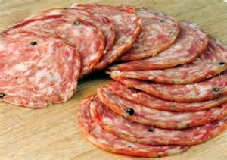
- Cheese
- Hard-boiled eggs
- Pate
- Salami
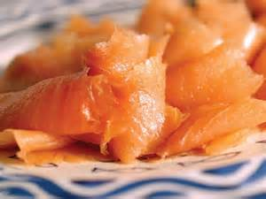
- Prosciutto
- Ham
- Smoked salmon
- Smoked trout
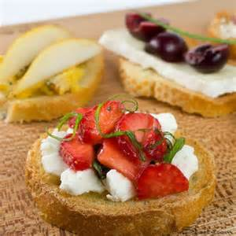
- Smoked oysters
- Sardines
- Fruits (melon, strawberry, kiwifruit, pineapple)
- Vegetables (avocado, tomato, mushroom).
A spread of cream cheese flavoured with a fruit or vegetable, cheese or egg can also be used. It is piped onto the base using a small star nozzle.
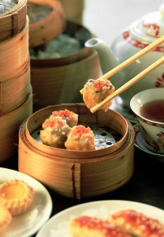
The garnish may be added for colour, e.g. herbs, capers, gherkins, olives, fish roe, fruit, vegetables cheese or toasted bread. E.g. Melba toast or croutons
Alternatively it may be added to moisten the body, e.g. mayonnaise, sour cream.
The size or amount of garnish must be in keeping with the size of the canapé, and not over dominate the canapé.
No matter what the garnish looks like its flavour must compliment the base and body of the canapé.
- Spanish Tapas
- Chinese Dim Sum
- Greek Meze.
These can all be classified as appetisers, or small snacks, smaller than an entree.

2.2 Prepare appetisers to enterprise standards including nutritional and eating qualities

Introduction
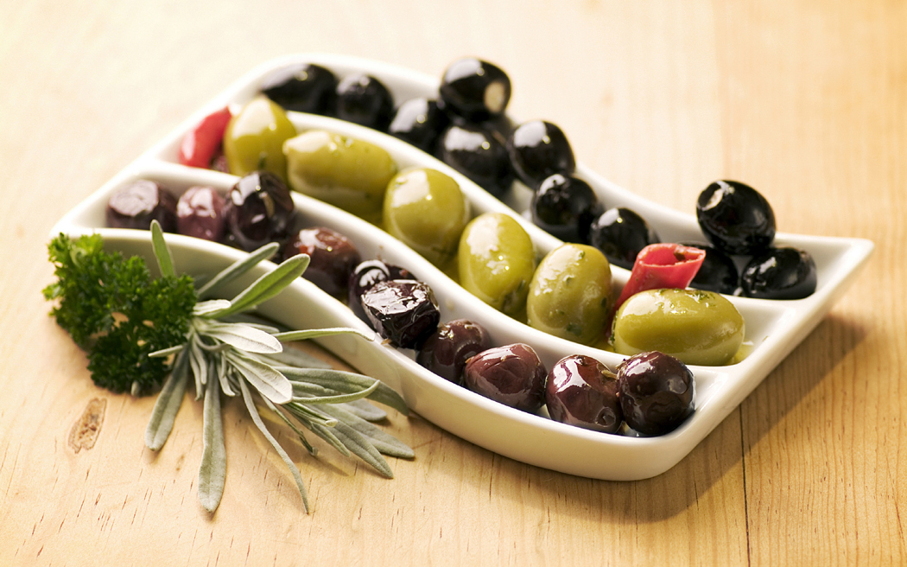
Many appetisers can be pre made and stored frozen for long periods of time.
Appetisers on wrapped in pastry will freeze well. Appetisers that have salad leaves in them will not freeze.
Appetisers can be cooked then frozen, thawed and re-heated as needed or they can be made then frozen, thawed and then cooked before being served.
When producing meats that are to be used as appetisers such as a satay, it is best to make them then freeze in thin layers that can easily be thawed and cooked to order.
When meats are cooked they tend to dry: so they are best cooked to order.
There can be confusion regarding exactly what is an appetiser.
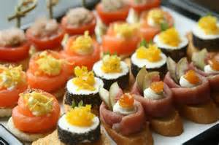
An appetiser is something that is served before the meal starts. Spanish tapas are an excellent example of this style of eating - one or two bites.
- Meat or main component of dish
- Salad, if desired
- Sauce, acidic is normal.
Develop a logical sequence to the preparation
- Do you have the storage capacity for required ingredients?
- Collect all required ingredients
- Prepare all ingredients as required
- Cook what needs to be cooked.
Not all components will need to be cooked.
- Prepare garnishes that are required.
Remember: When preparing for large number of customers, allow for:
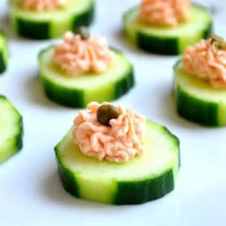
- Meat and non-meat dishes
- Ease of serving
- Finger food is one or two bites
- Toothpick and skewers need to be discard when the food is eaten
- A balanced selection is required
- What is your customer demographic?

2.3 Prepare garnishes, and accompaniments

Introduction
Garnishes for appetisers tend to be kept to a minimum.
Garnishes should be prepared on a daily basis as they lose their crispness as they age.
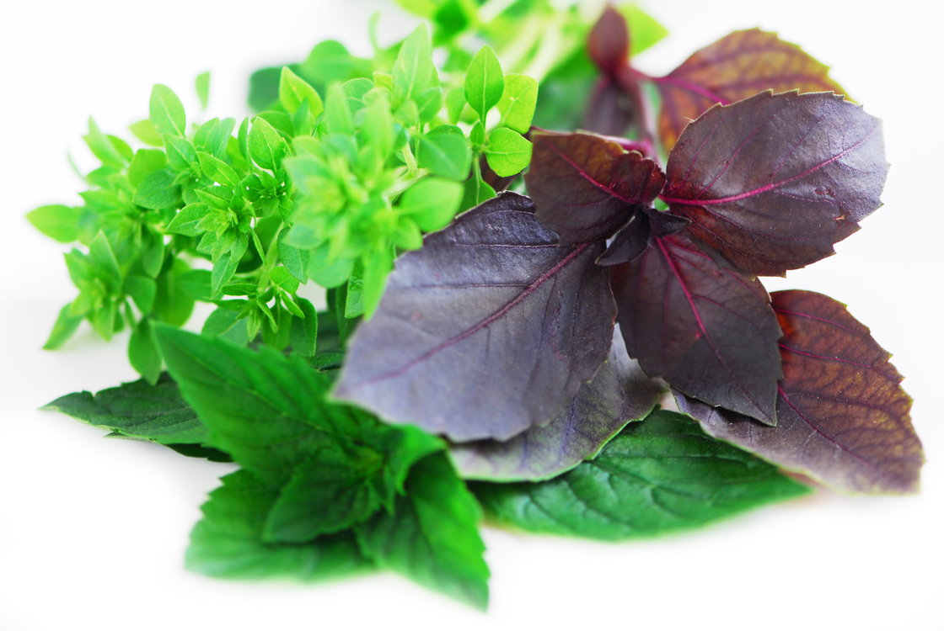
Absorbing moisture from the air, even if you store them in a special container, they will absorb moisture from the air every time you open the container.
The inside of the container also needs to be washed regularly, after each batch, to keep flavours fresh.
Hot meat or fish there will be a sauce:
- A grilled sausage (chorizo). 3 slices, served with warmed marinated black olives (3), then maybe a small piece of toasted or grilled sourdough.
Cold might have a salad and dressing or a cold sauce:
- Classic cured oily fish, Salmon or Tuna; Ocean trout gravalax served with lightly dressed salad with slivers of thinly sliced onion dusted with cracked black pepper and pink salt.
Garnishes
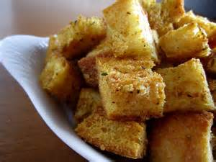
Examples:
- Croutons
- Fresh or fried herb leaves
- Roasted rice, ground to powder
- Roasted nuts.
Accompaniments
Example:
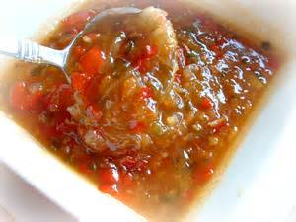
- Sauces
- Chutneys
- Toasted sourdough
- Pickled vegetables
- Marinated vegetables.
Do not spend too long preparing the garnish as most people will not eat the decoration.

2.4 Present hot and cold appetisers including garnishes and accompaniments according to enterprise standards

Introduction
Presentation should be simple and uncomplicated or innovative and complex.
Modern interpretation means that some innovative ways can be very complex and these are expensive to produce.
All this will depend on the enterprise and the point they situate themselves in the marketplace.
No matter what your marketplace your product should look appetising or ‘pleasing to the eye’.
If it does not look appetising but it taste ‘out of this world’, WOW, then the customer will enjoy the experience.
BUT if it fails on both points:
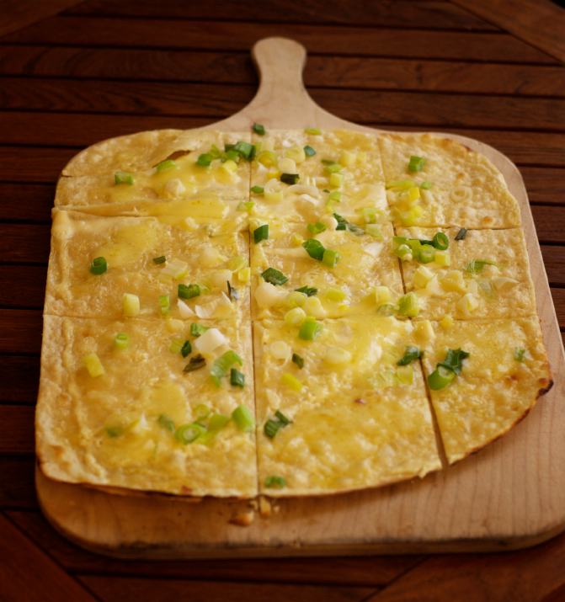
- Looks terrible
- Tastes average.
Then you will lose the customers return business.
Things to consider when presenting food:
- Cultural theme
- Colour
- Height
- Neat and attractive
- What is it served on:
- Ceramics plates: easy to clean, easy to replace if broken
- Pieces of wood: very trendy but hard to keep clean
- Glass: looks good but can be fragile
- Crystal: delicate and expensive to replace
- Mirrors; look spectacular, but heavy and looks messy when half the food is gone
- Trays: durable and forgiving if dropped
- How easy is it to prepare and serve?
- What equipment do staff need to serve:
- Tongs and lifters for ease of service
- Trolley to move large mirrors
- Where will all these extra things be stored?
Work Projects
It is a requirement of this Unit you complete Work Projects as advised by your Trainer. You must submit documentation, suitable evidence or other relevant proof of completion of the project to your Trainer by the agreed date.
2.1 Write a menu for 6 hot appetisers and 6 cold appetisers.
You will need to present a list of all the ingredients required to be purchased to meet his menu you have developed.
You may choose from the recipes in back of training manual if you wish or you may choose to select your own:
- Be sure to make allowances for variety of tastes
- Do not have all meat flavours
- Do not have all vegetarian.
2.2. Prepare 3 from each section (hot and cold).
2.3. Prepare suitable garnishes and accompaniments to compliment what you have produced.
2.4. Present you selection to your trainer for evaluation:
- Is the presentation in keeping with the expectation of your client base
- Is the quality of presentation consistent across all dishes.

Summary

Prepare and present a selection of hot and cold appetisers
Select ingredients to meet requirements of hot and cold appetisers menu items
Select the quality of the ingredients you need to produce to meet the expectation of your clients
Purchase only what you need to fulfil production requirements
Time purchases to meet production requirements and storage capacity.
Prepare appetisers to enterprise standards including nutritional and eating qualities
Prepare only what you need to meet customer expectations.
Variety of preparation techniques need to be undertaken to meet customer demands
Fried
Steamed
Grilled
Baked
Marinated and cured.
Prepare garnishes, and accompaniments
Garnishes need to be fresh. Garnishes need to compliment the food with what they are being used
Accompaniments need to relate to the main element in the dish. They must not dominate but must compliment.
Present hot and cold appetizers including garnishes and accompaniments according to enterprise standards
Present in professional manner to meet customer expectations:
- Large platters need to be laid out in symmetrical patterns
- Do not put all of one variety on one side:
- Makes it hard for people to reach across
- Start in centre and fan to outside.

Element 3:
Store appetisers and salads including garnishes and accompaniments

3.1 Store under appropriate conditions and locations to ensure freshness and quality

Introduction
When the appetisers have been prepared then they need to be stored.
At what point the preparation is at is also very important:
- It is still raw?
- Is it cooked?
If it is raw then it needs to be kept separated from cooked. Never let the 2 of them mix.
All prepared foods must be kept chilled until you are ready to serve:
- Cool room should be 4°C or less
- Fresh foods should not be kept for longer than 3 – 5 days.
Some have a longer life than others. 3 days is preferable.
If prepared raw food is to be stored for longer than 3 days it is best to freeze the product on day 1:
- Freezing should be done when the product is wrapped in single layers and then frozen:
- This makes it easier to thaw when required
- Always freeze in batches of 10:
- Easier to counts when doing stock take
- Freezer should be operating at below -15°C or less (-18°C preferable):
- Never freeze for more than 3 months.
Salads cannot be frozen
Freezing only apply to pastry based items and meats.
Appetisers are always best if made fresh but this is not always possible when doing large numbers:
- Small samosas and mini shashliks can be prepared and frozen, cooked on the day.
Easy to store flat and thin, easy to thaw and cook.
Salad leaf should be washed and spun dry before being stored in plastic bag and held firmly in clean plastic containers and kept chilled until needed:
- 4 days maximum to maintain optimum quality.
Cooked root vegetables should be prepared as close to the date of use as possible:
- On the day or the day before best:
- Short life span.
Storage of Garnishes and Accompaniments
Like any other foods their storage requirements need to be considered. High risk foods need to be kept chilled below 4°C for no more than 3 days of frozen below -15°C (-18°C better) for longer time.
Garnishes like ‘crisped breads’ that do not require cold storage, can be stored in sealed containers at room temperature.
Care needs to be taken with the time being stored as flavour and texture can be altered due to absorption of moisture from the air.
Fruits that are being used for garnish need to be produce on the day.
Herbs picked are best used on the day or possibly the next. These need to be stored in containers with absorbent paper to keep moist.


3.2 Store in appropriate containers

Introduction
Keeping prepared products stored safely cannot be achieved if the containers in which they are contained are not suitable for the job.
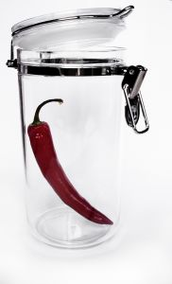
Storage containers must be clean and durable, impervious to liquids and must be in good condition:
- Storage container must be washable
- You must be able to sanitise them for future use
- They must be stackable for easier storage when not in use.
Stainless steel is the BEST containers for fresh meat storage:
- Cost is the biggest deterrent to using stainless steel.
Food grade plastic is second best storage containers, but they get scratched and need to be changed when the scratching is too bad as scratches can harbour bacteria.
Single plastic use items can be cost effective but must not be washed and re-used.
All storage containers must be able to be covered, either with a fitted lid or be small enough to be covered with plastic wrap to securely hold in product:
- Reduces spillage
- Reduces cross contamination
- Easier to affix labelling.
Best containers for storing large quantities of prepared product is large shallow containers that will take 1 or 2 layers:
- Too many layers will cause the uncooked product to squash when stacked. If they are frozen before they are stacked then that will be acceptable.
Follow FIFO rule. Stock rotation.

3.3 Labelling, storage containers

Introduction
When producing any product in a large establishment it is important to label correctly.
Labels should include the following.
Name of the product:
- Many people can be working in larger establishments and the person takes the product to the place of service may not be the person who prepared the product.
Date of Manufacture:
- This helps with keeping the flow of produce in correct order. First In First Out, Freshness.
Handler name
- Name of the person who was responsible for making the product. If any issues arise regarding quality then management knows whom to refer.
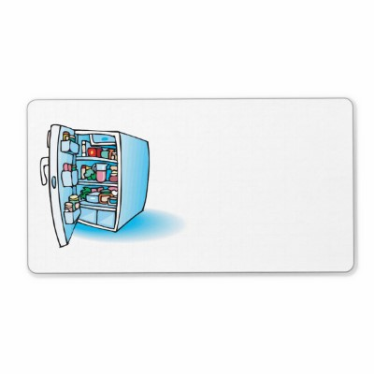
Time
- What time the product was stored
Temperature
- To maximise lifespan and quality it is important to guide others in the requirements in keeping optimum quality.
Storage
- How long this product should be stored before quality falls below enterprise standards.
Labelling of Spreads and Fillings
When product comes into the premises from outside suppliers they may be in boxes that have the name of the product on the box and not the package in which the food is contained inside that box.
These boxes are referred to as 'outers' and the inside packaging is referred to as 'inners'.
When removing inners from the outers it is important that the information on the outers is not lost so there may be a need to relabel the inner packaging.
Any ‘in house’ produced sauces and fillings will need to be labelled names, production dates and use by date.
Storage containers
Storage containers must be of a quality that can easily be washed, dried, stacked and stored securely.
They must be impervious to liquids and odours so as to not contaminate other foods that might be placed inside these containers.
Single use containers must not be re-used; example: Pizza boxes, drinking bottles, seafood delivery containers.
3.4 Ensure economic viability of preparation and holding quantities

Introduction
Economic viability determines all that is produced in the kitchen.
Food and labour costs are the biggest issues in the kitchen.
Some dishes will have food cost that are 40% of total selling price, some will be 15%. The accepted average in Australia is 28%-30% overall.
Some dishes sell well so they tend to have lower costs. Specials where the Chef is trying new dishes can carry higher cost.
Several questions need to be answered before you start producing food.
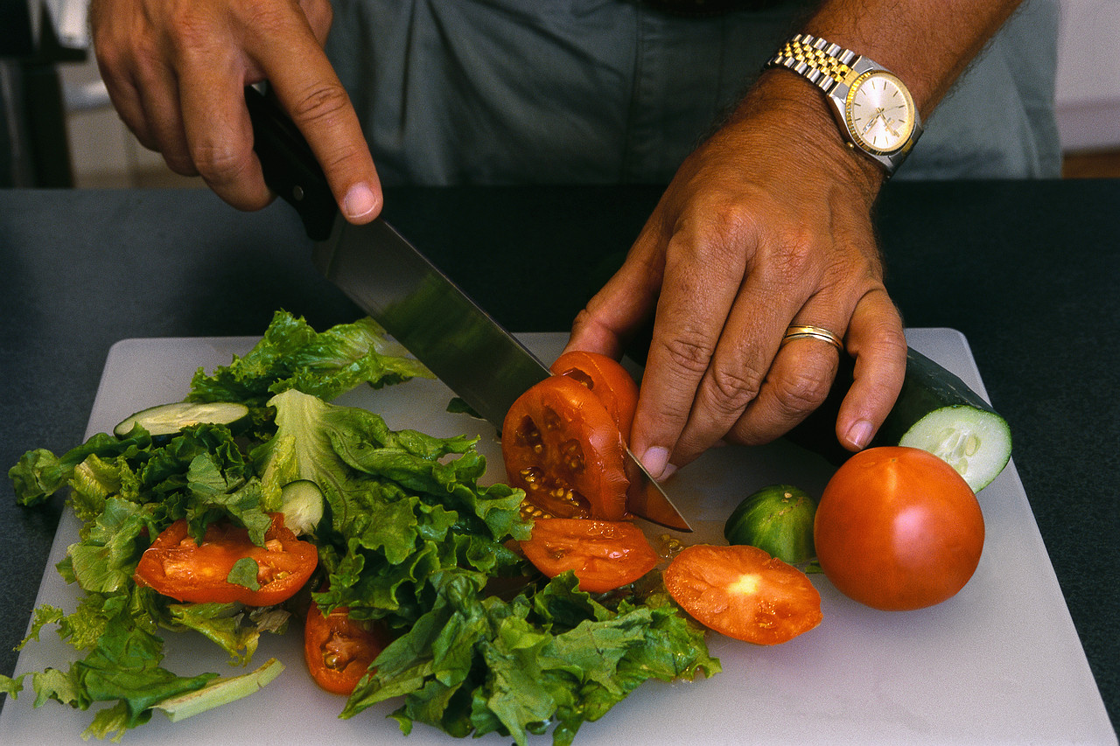
If I am going to produce 500 portions:
- Do I have the room to store them?
- How long will it take the business to use this many portions?
- Is it better to produce in smaller quantities?
- Is it cost effective to do this with the staff employed?
- Is it better than what I can purchase from outside?
Many questions can be asked when looking at producing food. Is it economically viable for the business to produce their own or is it cheaper to purchase from outside.
When the product is purchased from the outside, is there sufficient space to store the product until it is needed.
- Is it chilled?
- Frozen?
- Hot?

Work Projects
It is a requirement of this Unit you complete Work Projects as advised by your Trainer. You must submit documentation, suitable evidence or other relevant proof of completion of the project to your Trainer by the agreed date.
You need to write a report.
3.1 How are the appetisers that are produced going to be stored?
- What type of containers will be required?
- What information needs to go on the label?
3.2 What is your opinion on the economic viability of one of the appetisers you have chosen?
- Will this product sell in sufficient numbers to be worthwhile to be on menu?
- Does it suit the needs of the majority of you clients?
- Will it suit the image of your establishment?
- Can you produce these in numbers required?
- Do you have facilities to produce the numbers required?

Summary

Store appetisers and salads including garnishes and accompaniments
Store under appropriate conditions and locations to ensure freshness and quality
All perishable food is to be stored at 4°C or below. Stored food is to be protected from contamination, labelled and stored securely.
Frozen foods need to be kept frozen until required and then thawed in cool room. Some small prepared foods can be cooked from frozen.
Dry goods need to be stored in a secure environment so as to eliminate possibility of contamination until required.
Store in appropriate containers
Containers need to be clean and must be suitable to for the product that is being stored.
Containers should be impervious to liquids and easy to stack without compromising the integrity of the food inside.
Labelling, storage containers
All stored food needs to be labelled with the following information.
- Name of the product being stored
- Date of manufacture
- Use by or best before date
- Name of person who made the product
- Special requirements for the food being stored.
Ensure economic viability of preparation and holding quantities
Do not produce more than you can store securely
Do not produce what you cannot sell within a specified period
If you have no freezer space then only produce what you can sell within 2 days, then produce more as required.

Appendix A: Salads

Tomato, Basil, and Bocconcini Salad
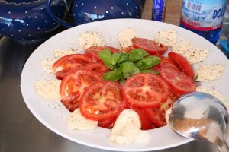
Caprese Salad
Ingredients
1 | Roma tomato
6 | basil leaves
2 | Bocconcini balls
40 ml | Extra virgin olive oil
20 ml | Balsamic vinegar
Method
- Slice the tomato into 5mm slices
- Slice the Bocconcini into the same number of slices as the tomato
- Chiffonade the basil leaves
- Arrange the tomato slices and Bocconcini slices on a cold plate, so they are alternating and slightly overlapping
- Sprinkle the basil over the top of the tomato and Bocconcini
- Drizzle the olive oil and vinegar over the salad and finish with cracked black pepper and sea salt.

Salad Nicoise
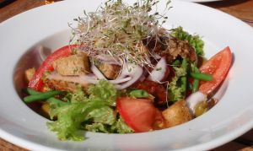
Ingredients
1 | Kipfler potato
50 gm | Blanched Green beans
4 | Cherry Tomatoes
55 ml | Olive oil
20 ml | Lemon juice
1 | Egg
50 gm | Pitted Black olives
80 gm | Tuna, grilled
Method
- Cook Kipfler in boiling salted water until tender, but still holding its shape
- Refresh Kipfler under cold water
- Once cool enough to handle, peel skin & and slice into bite size pieces (refer to demo)
- Blanched and refresh clean Green Beans
- Halve Cherry tomatoes
- Soft boil egg. (place in boiling water for 5 minutes, then refresh)
- Place all ingredients in a bowl (Tuna, Egg, Kipfler, Olives, Tomato, and Beans)
- Prepare vinaigrette (Olive Oil & Lemon Juice)
- Pour dressing into bowl, season salad and lightly toss
- Arrange neatly on a clean, cool plate.

Wombok Salad
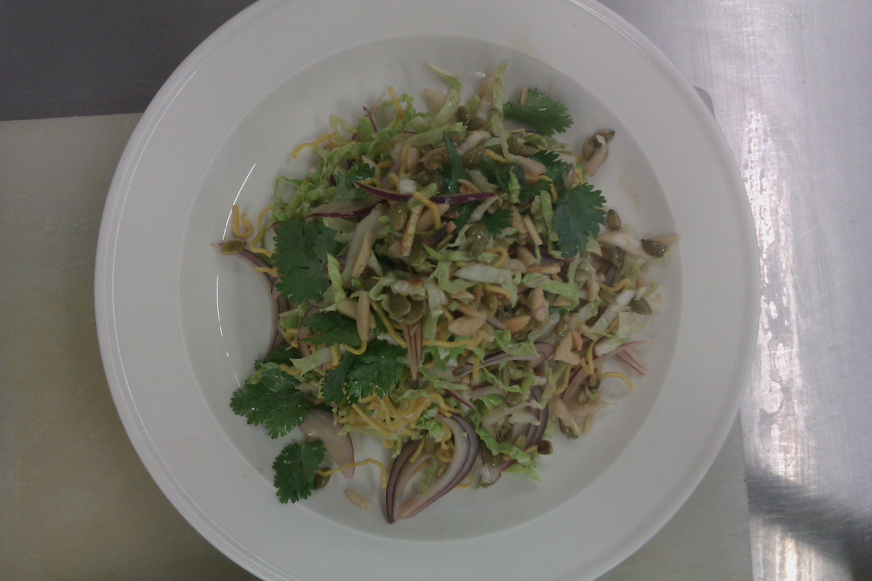
Ingredients
Dressing
10 gm | Castor Sugar
20 ml | Oil
10 ml | Light Soy Sauce
10 ml | White Vinegar
Few drops | Sesame Oil
Salad
100 gm | Wombok Cabbage (shredded
20 gm | Red Onion
15 gm | Pumpkin Seeds
20 gm | Slivered Almonds (roasted)
20 gm | Fried Noodles
8 -10 | Coriander leaves (picked & washed)
Method
- Mix dressing ingredients together and leave for at least 15 minutes, ensuring sugar is completely dissolved prior to use
- Wash and drain Wombok cabbage well. Shred Wombok & finely slice red onion
- Mix Wombok, onion, pumpkin seeds & almonds in a bowl
- Just prior to serving add dressing and some of the fried noodle, combine well
- Arrange neatly on a clean plate & garnish with coriander leaves and remaining noodles.

Caesar Salad
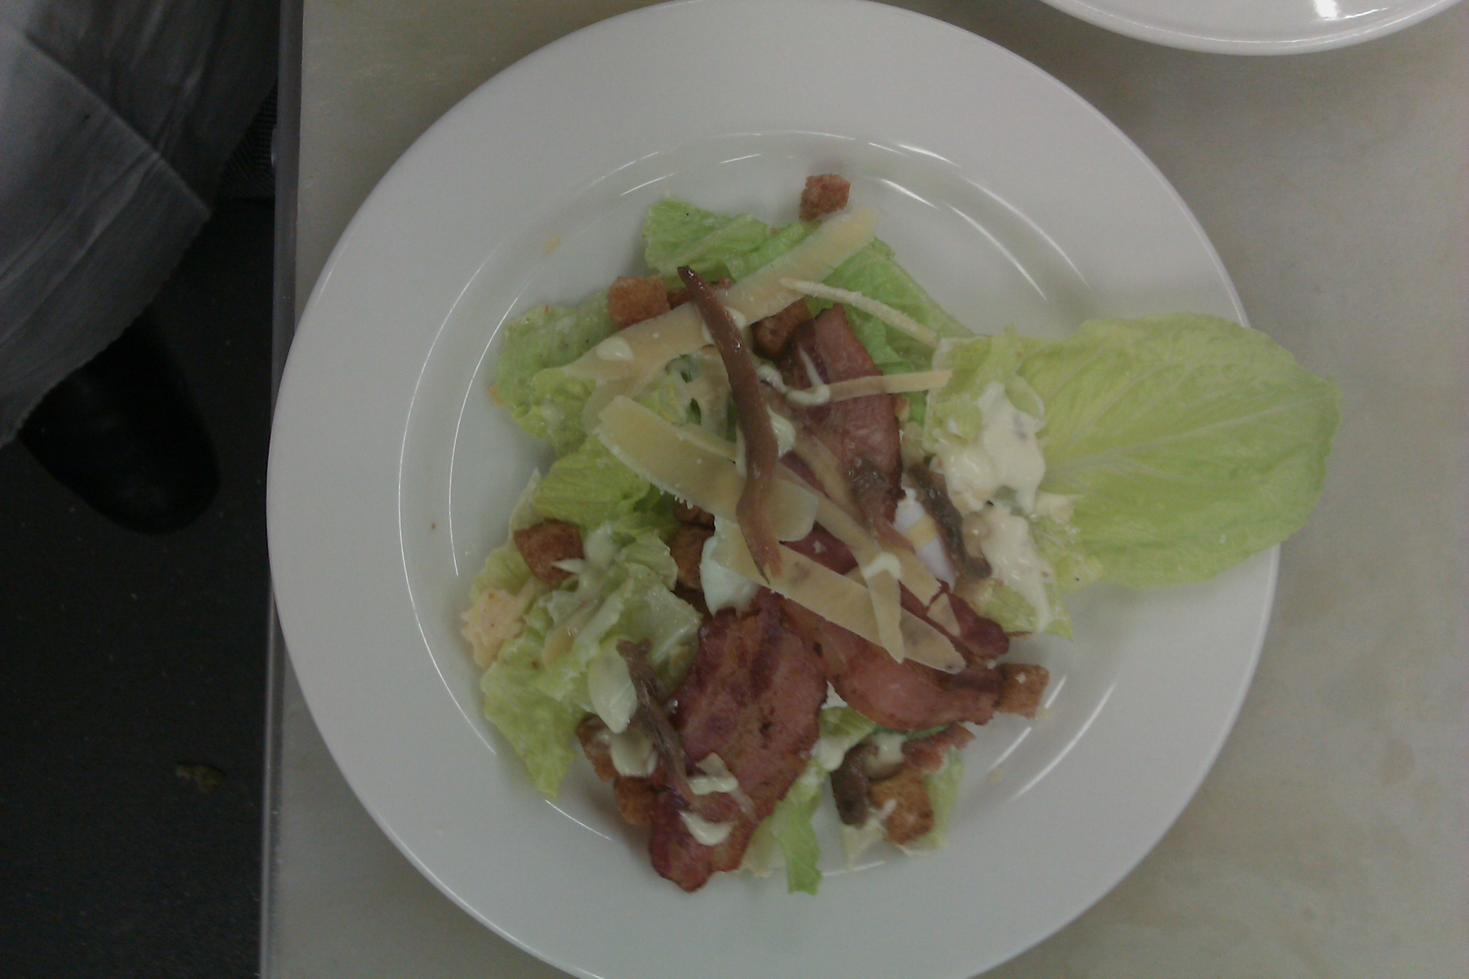
Ingredients
75 ml | Clarified butter
1 slice | White bread, 1 cm thick
75 ml | Olive oil
40 ml | Lemon juice
1 | Egg
trace | Salt and pepper, mustard and sugar
4-6 | Cos lettuce leaves
1 rasher | Bacon
2 | Anchovy fillets
25 gm | Parmesan cheese
Method
- Heat garlic and butter very gently in a frying pan. Add the bread and cook, turning until croutons are crisp and golden
- Cut bacon into lardons. Add to a hot pan and fry until crisp, drain well
- Boil egg for 2 minutes, break into a bowl add olive oil, lemon juice, mustard, sugar and seasoning and mix well
- Wash and dry the cos lettuce, tear into pieces
- Cut anchovies into small pieces
- Shave parmesan cheese
- Place lettuce, anchovy and cheese in a bowl pour over the dressing and mix well
- Serve in a bowl and scatter croutons, bacon and cheese on top.

Appendix B: Appetisers

Bruschetta with Tomato, Basil and Red Onion
Ingredients
1 slice | Pasta Dura
2 – 3 | Roma Tomato
15 gm | Red Onion (finely diced)
4 | Kalamata Olives (Sliced into cheeks)
pinch | Cracked Pepper
pinch | Maldon Sea Salt
3 | Medium Sized Basil Leaves
25 ml | Olive Oil
5 – 10 ml | Balsamic Vinegar
½ | Clove of Garlic (crushed)
Method
- Slice the bread, brush with olive oil & then grill both sides on a French grill
- Finely dice tomatoes and red onion & mix in a bowl
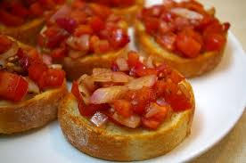
- Slice olives and add to tomato & onion
- Add garlic, salt, pepper, oil and vinegar
- Leave aside for at least 15 minutes
- Deep fry one basil leaf for garnish
- Just prior to serving, add torn basil leaves and mix well, taste and adjust seasoning
- On a clean plate place the grilled bread
- Top with the tomato mix and garnish.

Vietnamese Rice Paper Rolls with BBQ Pork
2 portions
Ingredients
6 | Rice Paper Wrappers
60 gm | Rice Vermicelli (soaked in boiling water)
60 gm | BBQ Pork
60 gm | Bean Shoots
6 | Mint Leaves
6 | Holy Basil Leaves
6 | Garlic Chive Spears
30 gm | Cashews
Method
- To soften rice paper wrappers, dunk into warm water briefly and drain well
- Cover with a damp cloth or glad wrap
- To assemble the rolls, place 1 piece of rice paper flat on the bench
- Arrange some strands of vermicelli, bean shoots, a mint leaf, a basil leaf, cashews, BBQ pork
- Fold the rice paper over forming a semi-circle & place a garlic chive on rice paper and roll up firmly
- Keep rolls covered to avoid drying out
- Serve on a clean plate with Nam Prik and garnish.

Pandan Chicken
Ingredients
3 | Pandan leaves
1 tsp | Red curry paste
2 | Coriander root chopped very fine
1 | Chicken thigh fillet
Method
- Cut Pandan leaves in half, reserve one leaf to make ties

- Cut the chicken fillet into approximately four portions
- Mix curry paste and coriander root
- Marinate chicken in spice mix for approximately 30 minutes
- Wrap as shown in the demonstration
- Deep fry until cooked, drain well
- Serve with sweet chilly lemon sauce.

Wontons
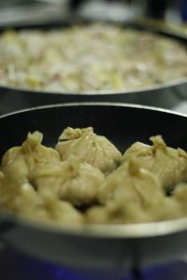
Ingredients
70 gm | Pork mince
2 tsp | Coriander, chopped
1 slice | Ginger, grated
1 clove | Garlic, crushed
2 | Spring onion, finely sliced
Pinch | Chinese 5 spice powder
5 ml | Soy sauce
1 | Water chestnut, chopped fine
6 | Wonton wrappers
Method
- Mix together the pork mince, coriander, ginger, garlic, spring onion, 5 spice, soy and water chestnut
- Place the wonton wrappers on the bench
- Shape the pork mix approx 1 tsp each to a round ball and place in the centre of the wonton wrapper
- Dampen edges with water
- Fold the edges over the top and press together firmly
- Steam for 10 – 15 minutes
- Serve hot, with a soy sauce for dipping.

Chicken Satay
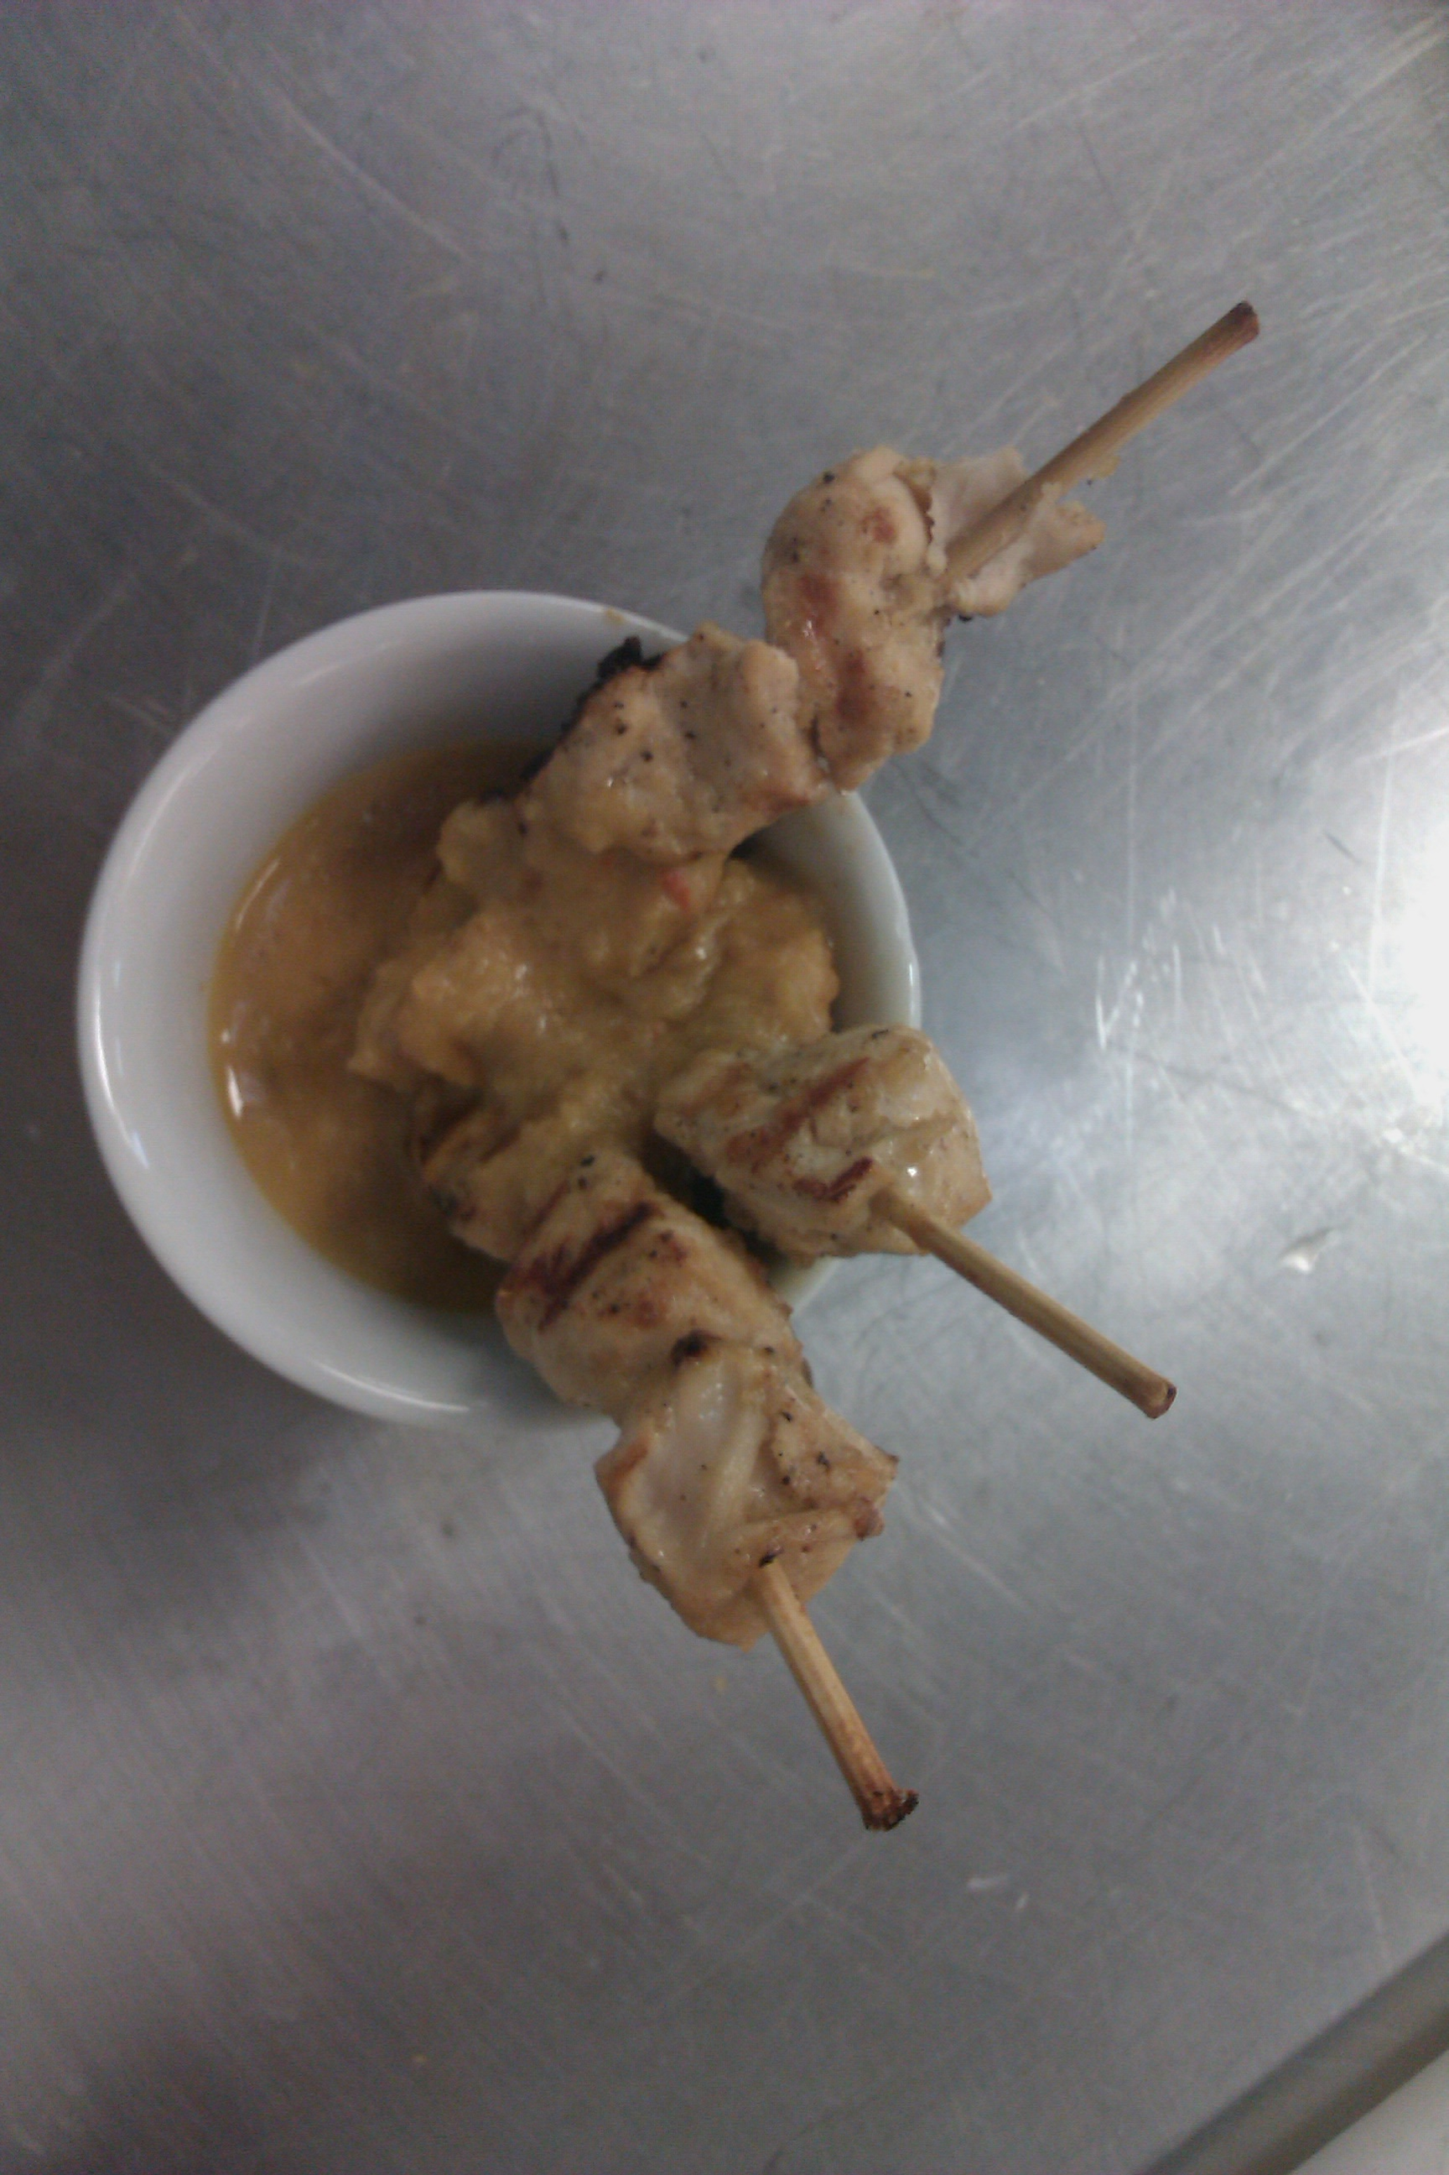
Ingredients
60 gm | Chicken breast or thigh meat
Marinade
1 clove | Garlic, chopped
1 tsp | Coriander
1 tsp | Brown sugar
¼ tsp | Black pepper
½ tsp | Salt
1 tsp | Soya sauce
1 tsp | Ginger, chopped
2 tsp | Lime juice
½ tsp | Oil
 | Fresh coriander, chopped (for garnish)
Method
- Mix marinade ingredients. Cut chicken into 1-2 cm cubes.
- Add to marinade mixture and marinate at least two hours
Chicken Satay
- Thread chicken pieces onto one end of satay sticks
- Grill or broil, baste with marinade
- Serve with satay sauce for dipping in a side bowl.

Spinach and Feta Cheese Triangles
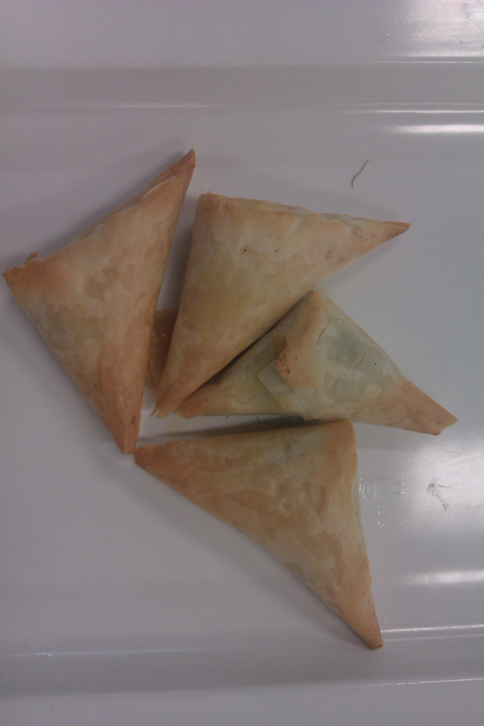
Ingredients
30 gm | Spinach
20 gm | Feta cheese
15 gm | Bacon
15 g | Onion
Pinch | Nutmeg
1 sheet | Filo pastry
20 ml | Clarified butter
Method
- Remove stalks, wash and roughly chop the spinach
- Wilt the spinach in a hot sauté pan and cool
- Squeeze out the excess moisture
- Finely dice the onion and chop bacon finely
- Sweat the onion and bacon, leave to cool
- Mix spinach, feta, onion, and bacon together in a bowl, add seasoning and nutmeg
- Brush the filo sheet with clarified butter
- Cut the sheet across into 6 equal strips
- Fold the triangle parcels as shown in the demo & brush with a little clarified butter
- Place on a baking tray & bake in a hot oven until golden brown.

Lime leaf chicken
Ingredients
100 gm | Minced chicken
20 ml | Lime juice
20 ml | Peanut oil
2 | Kaffir lime leaf (1 left whole, 1 finely julienne)
½ | Chilli birds eye (finely chopped)
½ | Spring onion (finely sliced)
1 tsp | Mint (shredded)
10 ml | Thai fish sauce
Method
- Sauté chicken mince in half peanut oil with 1 whole lime leaf until the mince is cooked through
- Add half lime juice and cook for a further 5 minutes on a medium heat
- Allow to cool & stir in the remainder of ingredients.
To serve:
Place into prepared pastry cup or into a spoon for individual serves.

Presentation of written work

1. Introduction
It is important for students to present carefully prepared written work. Written presentation in industry must be professional in appearance and accurate in content. If students develop good writing skills whilst studying, they are able to easily transfer those skills to the workplace.

2. Style

Students should write in a style that is simple and concise. Short sentences and paragraphs are easier to read and understand. It helps to write a plan and at least one draft of the written work so that the final product will be well organised. The points presented will then follow a logical sequence and be relevant. Students should frequently refer to the question asked, to keep ‘on track’. Teachers recognise and are critical of work that does not answer the question, or is ‘padded’ with irrelevant material. In summary, remember to:
- Plan ahead
- Be clear and concise
- Answer the question
- Proofread the final draft.

3. Presenting Written Work
Types of written work
Students may be asked to write:
- Short and long reports
- Essays
- Records of interviews
- Questionnaires
- Business letters
- Resumes.
Format
All written work should be presented on A4 paper, single-sided with a left-hand margin. If work is word-processed, one-and-a-half or double spacing should be used. Handwritten work must be legible and should also be well spaced to allow for ease of reading. New paragraphs should not be indented but should be separated by a space. Pages must be numbered. If headings are also to be numbered, students should use a logical and sequential system of numbering.
Cover Sheet
All written work should be submitted with a cover sheet stapled to the front that contains:
- The student’s name and student number
- The name of the class/unit
- The due date of the work
- The title of the work
- The teacher’s name
- A signed declaration that the work does not involve plagiarism.
Keeping a Copy
Students must keep a copy of the written work in case it is lost. This rarely happens but it can be disastrous if a copy has not been kept.
Inclusive language
This means language that includes every section of the population. For instance, if a student were to write ‘A nurse is responsible for the patients in her care at all times’ it would be implying that all nurses are female and would be excluding male nurses.
Examples of appropriate language are shown on the right:
Mankind | Humankind
Barman/maid | Bar attendant
Host/hostess | Host
Waiter/waitress | Waiter or waiting staff

Recommended reading
Better Homes & Gardens; 2011; The Ultimate Appetizers Book; Better Homes & Gardens
Blake, Susannah; 2007; 500 Appetizers: The Only Appetizer Cookbook You'll Ever Need; Sellers Publishing
Blake, Susannah; 2010; 500 Salads: The Only Salad Compendium You'll Ever Need; Sellers Publishing
Cersani, Kinton & Foskett; 1995 (8th edition), Practical Cookery; Hodder and Stoughton
Chandler, Jennifer; 2007;Simply Salads; Thomas Nelson
Fine Cooking Magazine; 2010; Fine Cooking Appetizers: 200 Recipes for Small Bites with Big Flavor; Taunton Press
Fox, Mindy; 2012; Salads: Beyond the Bowl; Kyle Books
Instructables Authors; 2011(Kindle edition); Easy Appetizer Recipes; Instructables.com
McLean.D,Satori.l, Walsh C&S; 2004;The Professional Cook’s book: Commercial Cookery; Tertiary Press
McWilliams, Margaret; 2013 (10th edition); Food fundamentals; Pearson
Printz, Stacy; 1998; The Best 50 Salad Dressings; Nitty Gritty Cookbooks
The Culinary Institute of America (CIA); 2011 (9th edition); The Professional Chef; Wiley
The Culinary Institute of America (CIA); 2014 (4th edition); Techniques of Healthy Cooking; Wiley
Walthers, Catherine;2007; Raising the Salad Bar; Lake Isle Press

Trainee evaluation sheet

Prepare appetisers and salads
The following statements are about the competency you have just completed.
Please tick the appropriate box | Agree | Don’t Know | Do Not Agree | Does Not Apply
There was too much in this competency to cover without rushing.
Most of the competency seemed relevant to me.
The competency was at the right level for me.
I got enough help from my trainer.
The amount of activities was sufficient.
The competency allowed me to use my own initiative.
My training was well-organized.
My trainer had time to answer my questions.
I understood how I was going to be assessed.
I was given enough time to practice.
My trainer feedback was useful.
Enough equipment was available and it worked well.
The activities were too hard for me.

The best things about this unit were:

The worst things about this unit were:

The things you should change in this unit are:

Trainee Self-Assessment Checklist
As an indicator to your Trainer/Assessor of your readiness for assessment in this unit please complete the following and hand to your Trainer/Assessor.

Prepare appetisers and salads
 |  | Yes | No*
Element 1: Prepare and present a selection of hot and cold salads
1.1 | Select ingredients to meet requirements of hot and cold salad menu items
1.2 | Prepare salads to enterprise standards including nutritional and eating qualities
1.3 | Prepare garnishes and accompaniments
1.4 | Present salads including garnishes and accompaniments according to enterprise standards
Element 2: Prepare and present a selection of hot and cold appetisers
2.1 | Select ingredients to meet requirements of hot and cold appetisers menu items
2.2 | Prepare appetisers to enterprise standards including nutritional and eating qualities
2.3 | Prepare garnishes, and accompaniments
2.4 | Present hot and cold appetisers including garnishes and accompaniments according to enterprise standards
Element 3: Store appetisers and salads including garnishes and accompaniments
3.1 | Store under appropriate conditions and locations to ensure freshness and quality
3.2 | Store in appropriate containers
3.3 | Labelling, storage containers
3.4 | Ensure economic viability of preparation and holding quantities

Statement by Trainee:
I believe I am ready to be assessed on the following as indicated above:
Signed: | _____________________________ | Date: | ______ / ______ / ______
Note:
For all boxes where a No* is ticked, please provide details of the extra steps or work you need to do to become ready for assessment.





